**CP Club 365 Days Challenge**

**Programming language – C++**

**Problem Statement**

<https://www.codechef.com/DSAPREP_01/problems/KNGATK>

**Your Code**:

// 0x76Day of 0x365Days challenge

// VEDANT BHARAD

// 1-1-2023

#include <bits/stdc++.h>

#include <vector>

using namespace std;

int main() {

    int t;

    cin >> t;

    while (t--) {

        int n;

        cin>>n;

        int arr[n];

        for (int i = 0; i < n; i++) {

            cin >> arr[i];

        }

        sort(arr, arr + n);

        cout<<arr[1]<<endl;

    }

    return 0;

}

**Output (Screen Shot)**:

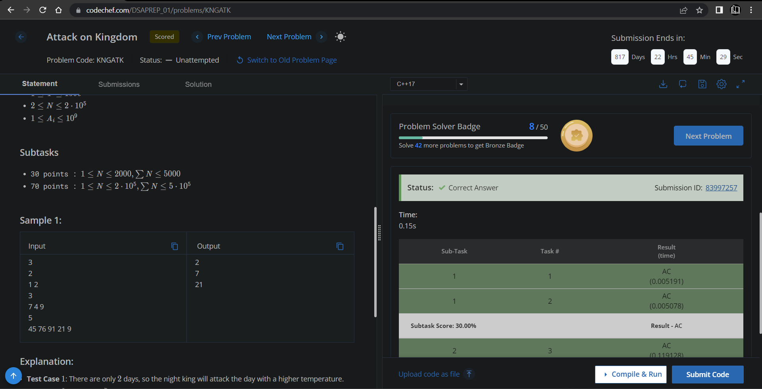

**Understanding about problem:**

**In this task I need to return second largest element of given array.**

Note: If you can't understand the problem, feel free to contact us and we'll help you. Please don't copy and paste from anywhere.

ALL THE BEST

Team CP Club